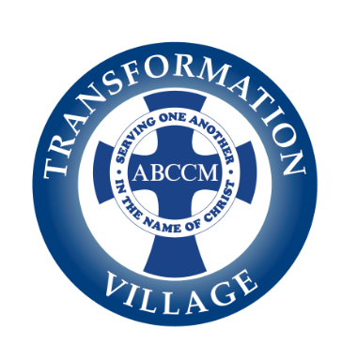

**Transformation Village 2024 Run for Hope**

**Letter from the Director**

What: Second Annual **Run for Hope**

When: May 19, 2024

Where: Biltmore Estate, Asheville NC

We are pleased to announce our second year participating in the Biltmore Kiwanis Classic 5k/15k to benefit the women and children we serve at ABCCM’s Transformation Village in Asheville, NC.

**ABCCM Transformation Village provides up to 100 beds of transitional housing for homeless women, mothers with children, and Veterans.**

* 90% of our moms have regained custody of their children.
* In 2023, we served 151 women, 34 of whom were moms, and 47 children.
* Through a partnership with AB Tech, in the last two quarters, 49 residents enrolled in college, GED, or job training courses, were provided with laptops, and/or received subsidized tuition and registration.
* Within a year of arriving at TrV, 8 out of 10 women found a good job and settled into permanent housing.
* 97% of former residents are still sober, housed and working two years after successfully completing our program.
* 350 volunteers currently serve in all aspects of Transformation Village, including Child Enrichment, Cook Teams, Code Purple, and many more, sharing their time and talents to help transform the community just by being here for our ladies.

**How you can help -**

**The Transformation Village Run for Hope runners need your support! Please consider sponsoring the race or a runner today. Visit our website at** [**https://www.abccm.org/donations/transformation-village-run-for-hope/**](https://www.abccm.org/donations/transformation-village-run-for-hope/) **to make a donation OR download and print one of the following forms to become a corporate sponsor or mail your donation:**